Flip and Count Addition and Subtraction
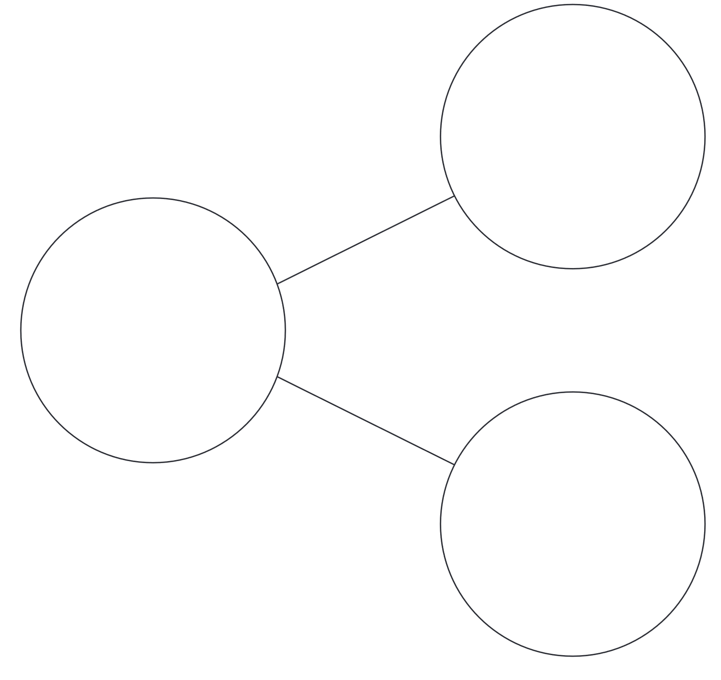
_________ + __________ = __________
_________ + __________ = __________
_________ - __________ = __________
_________ - __________ = __________
Flip and Count Addition and Subtraction Directions
Number Bonds to 10 with Fact Families

Materials: Number bond sheet with room for equations and 2 color counters (can use pennies: heads and tails)

Directions:
- Students shake up to 10 counters.
- Put one color in one part and the other color in the other part of the Flip and Count number bond sheet.
- Write the 2 addition fact families.
- Move the counters to the whole and write the 2 subtraction fact families.
- Continue until all combinations have been found.

Example:
- Shake 9 pennies and get 4 heads and 5 tails.
- Put 4 heads in one part and 5 tails in the other part.
- Write 4 + 5 = 9 and 5 + 4 = 9.
- Without flipping any coins over, move them all to the whole.
- Write 9 – 5 = 4 and 9 – 4 = 5.
- Shake all the pennies again and repeat with a different combination.

Extensions:
- Vary the number of counters to practice bonds for other numbers.

